**DESIGNING REBORN MENTAL HEALTH APPLICATIONS USING LEAN UX METHODS**

1Muhammad Rizal Ramdhani, 2Agus Salim, 3Muhammad Yan Handita

Universitas Pembangunan Nasional Veteran Jawa Timur, Jl. Rungkut Madya No.1, Gn. Anyar, Kec. Gn. Anyar, Surabaya, Jawa Timur

[rizalramdhanimuhammad@gmail.com](mailto:rizalramdhanimuhammad@gmail.com)

*abstract*

*Faster technology is essential today in terms of providing and presenting information sources. The rise of social media and all its sources and platforms is one of the drivers for this research. Mental health issues further form the background of this research. The Reborn app promotes the use of technology and is designed for people with mental health issues who need quick advice and professional treatment. The Lean UX model is a good method because it helps to achieve success and success faster when designing apps. The results obtained in this research constitute the final prototype and will be verified in terms of criticism and suggestions through a questionnaire as part of the evaluation of the Reborn app. Positive UX and good usability are essential for the further development of the application prototype. the results of the UI usability value are excellent with an SUS score of 82, which is above average and accepted by users.*

*Keyword: LeanUX, UI/UX, SUS, Prototype*

**Introduction**

* 1. UI/UX Design Idea Background

The rapid development of technology is inevitable. Providing and presenting easier sources of information has now become commonplace. The rise of social media and all its sources and platforms is one of the drivers of this research. Mental health issues are increasingly becoming the background of this research. The Reborn app promotes the use of technology and targets people with mental health issues. The main goal of the app is to process consultations quickly and professionally and provide quick solutions.

Reborn is a mobile-based mental health app that helps people who are facing personal problems. Reborn also helps to maintain happiness and productivity in everyday life.

The design of the Reborn app required user interface (UI) and user experience (UX) design. The user interface (UI) is the way an application interacts with the user. The user interface includes several elements of an application, such as controls, buttons, blocks, and all elements in the application [1]. The purpose of this user interface is to enable simple, pleasant, and effective interaction between the user and the application [1]. User Experience (UX) provides experience to users regarding the ease of use of an application. Creating UX is defining how a product works and meets user needs, and UX should be clear, pleasant, and user-friendly [1][2].

There are various methods for UI/UX design. This research uses the Lean UX model. It is a good way to minimize and even eliminate waste of time, energy, and materials, thus contributing to faster success. The advantages of Lean UX are faster, smarter UX, exploration and learning, and the ability to test many hypotheses depending on the user's wishes and this method [3]. The Lean UX methodology approach involves users in the development process by creating a minimum viable product (MVP) for testing, allowing them to provide feedback on the interface design and improve it. Lean UX also focuses on reducing unnecessary processes from the development cycle and improving the user experience at each iteration without spending too much time on documentation [3][4]. Research shows that designing and developing prototypes using Lean UX techniques provides a better user experience and is more acceptable to users. This is an indicator and comparison that the use of Lean UX techniques makes it easier for researchers to develop products that are acceptable to users [5].

This UI/UX design is expected to be a useful recommendation in developing the Reborn application in the future and become a solution for users from the existing obstacles in the application.

1.2 State of Art

Previous research can help to analyse and enrich the research discussion as well as differentiate it from the current research. This research covers five international journals of previous research related to Lean UX. previous research includes:

The first research was titled Optimizing Financial Technology (Fintech) with Lean UX Development Methodology to Support Technical Vocational Education and Financial Management [6]. The methodology used is Lean UX, which consists of four phases: declaring a hypothesis, developing an MVP, conducting experiments, providing feedback, and user research. The result of this study is an Android mobile application that can display fintech information and promotions. Lean UX development is done in his two iterations to produce functionality that users need but requires further development from a user experience perspective.

The second research is entitled "Prototype Design of the Alert Mother Application User Interface" and uses Lean UX [4]. In this research, we used the Lean UX methodology approach as a process of designing a prototype user interface for the Ibu Siaga application, conducted two tests with independent or team methods, and two types of tests to get feedback from users, namely SEQ and SUS questionnaires. The usability test results were "easy to use" on the SEQ questionnaire and "good enough" on the SUS questionnaire.

The third research is entitled "Designing Web Dictionary Information Services User Interface/User Experience Using the Lean User Experience (Lean UX) Method at Pamran University" [1]. Use the Lean User Experience (Lean UX) method in a four-step loop process to state assumptions, create MVPs, experiment, provide feedback, and conduct research. From this research, it is clear that user influence on app development is one of the factors that determine whether an app is worth using or needs improvement. By repeating the experiments and continuing the design, the desired application is created.

The fourth research is entitled "Implementation of Lean UX Methodology and Its Positive Impact on the Development of Android-Based Educational Games About Chemical Binding Materials" [7]. Developing educational games using the Lean UX methodology. It ends by explaining assumptions, creating MVP, conducting experiments, providing feedback and research, and delivering conclusions and recommendations. The test results of the developed game show that it has a positive impact on student learning achievement, especially on the teaching material "Chemical Bonding". This positive influence is based on the test using a Sig. value of 0.003. Because this significance level is below the confidence level (0.05), it can be seen that there is a significant difference in the average level of learning success due to the use of educational games made with Lean UX techniques.

The fifth research titled "Application of Lean UX and Design Sprint Methods in the Creation and Development of Aryanna Application" [2], uses Lean UX to save time and costs. It shortens and simplifies the UI/UX design process, making it competitive even for startups. After using the Lean UX methodology and two revisions, 90% of users who participated in the test felt that the Aryanna app already had a good level of usability.

**Research Methods**

2.1 Software Development Methodology

The research methodology used is the Lean UX method with Thinking Aloud and System Usability Scale testing*.*

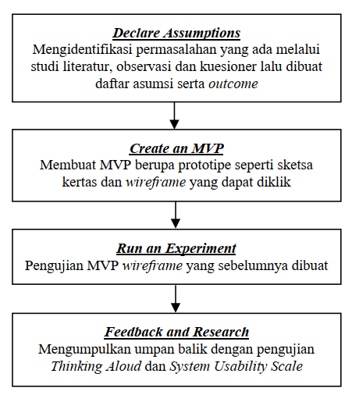

Figure 1 Research Methodology

2.2 Lean UX

Lean UX is a design management system that aims to support design through collaboration between teams, process iteration, and frequent contact with users [2]. Lean UX methodology is similar to agile methodology and user-centred design methodology. The Lean UX methodology is based on three important foundations: design thinking, agile software development, and lean startup [8]. By combining these elements, the Lean UX methodology takes a responsive, iterative, and user-centred approach to create effective and innovative user experiences in product and service development [8]. User experience (UX) refers to how users interact with a product or service. Whether the system usage experience is user-friendly, simple, and easy to understand, and how effective and efficient the interaction with the product is [9]. UI/UX has a variety of methods provided to help the process of completing the user interface design of an application. Common methodologies in UI/UX development include Lean UX, Double Diamond, Design Thinking, and User-Centered Design[10].

The goal of using Lean UX is to produce products tailored to the target market as quickly and cost-effectively as possible [11]. This method focuses on finding the fastest way to achieve the final goal through four design phases: stating assumptions, creating MVPs, conducting experiments, and providing feedback and exploration[12][13]. Based on this statement, Lean UX brings fundamental changes in the creation of product designs that are different from other methods. The use of this method is expected to result in faster and needs-based planning. Lean UX is a highly data-oriented process with minimal use of assumptions. Therefore, decisions become more accurate and the final quality increases [14]. The Lean UX workflow includes a one-step process: a review that evaluates design solutions using usability testing techniques [15].

2.3 System Usability Scale

System Usability Scale (SUS) is a measure that estimates the usability of a product. SUS has a questionnaire that contains 10 items. Each item has 5 answer options, namely strongly disagree, disagree, undecided, agree, and strongly agree with a point range of 1 to 5 [16]. How to calculate the SUS score for items 1, 3, 5, 7, and 9 the score contribution is the scale position minus 1. In items 2, 4, 6, 8 and 10 the contribution is 5 minus the scale position. Multiply the total score by 2.5 to get the overall system usability score. The score results range from 0 to 100 [16]. Codes R1, R2, R3, and so on are codes that represent each question on the SUS questionnaire, which will be used when calculating the SUS score. The formula for calculating the SUS score is as follows [16]:

𝑆𝑘𝑜𝑟 𝑆𝑈𝑆 = ((𝑅1 − 1) + (5 − 𝑅2) + (𝑅3 − 1) + (5 − 𝑅4) + (𝑅5 − 1) + (5 − 𝑅6) + (𝑅7 − 1) + (5 − 𝑅8) + (𝑅9 − 1) + (5 − 𝑅10)) ∗ 2,5

The results of a single assessment should be considered complementary to the SUS assessment, and the results should be used in combination to get a clearer picture of the overall usability of the product [16]. SUS is commonly used to determine user awareness of an application or product using surveys [4].

Table 1 shows the SUS level scale that measures UI/UX with low, medium, and high perceived usability [14]. Click or tap here to enter text.

Table 1 Grade Scale SUS

|  |  |
| --- | --- |
| SUS Score Range | Grade |
| 84.1-100 | A+ |
| 80.8-84.0 | A+ |
| 78.9-80.7 | A- |
| 77.12-78.8 | B+ |
| 74.1-77.2 | B+ |
| 72.6-74.0 | B- |
| 71.1-72.5 | C+ |
| 65.0-71.0 | C+ |
| 62.7-64.9 | C- |
| 51.7-62.6 | D |
| 0.0-51.6 | F |

**Result and Discussion**

3.1 Observation and Literature Study

Based on the literature study received by the researcher, it can be concluded that a good application is a user-friendly application. This means that the application should work easily so that the user does not face any difficulties. This is influenced by the user interface and user interface. User experience [1].

At this stage the researcher uses the observation method, directly observing the Reborn application to find out the processes that run in the application. In addition, researchers conducted experiments with existing functionality to see the shortcomings of the application.

3.2 Declare Assumption

The declare assumption phase consists of direct observation and distributing questionnaires to the surveyed users. After the scope of the problem is determined, initial assumptions are made that serve as a starting point for problem identification. Assumptions include questions about opinions, ideas, and problems faced by users when using an application or website [11].

In the assumption declare refers to the results of interviews that have been conducted previously, several assumption points are obtained: Users need an application for mental health consultations anywhere and anytime; An application that doesn't have too many menus and is easy to use; With a good user interface and user experience, the Reborn application can make things easier for users; With a comfortable and user-friendly user interface and user experience, easy access to the smartphone application will make it easier for users to maximize the Reborn application.

The next step is to build a scenario context in the form of a wireframe to determine user behaviour when interacting with the system, as follows: Target users are the general public who are experiencing mental health disorders; The target users (community) are active smartphone users.

3.3 Create Minimum Viable Product (Activity Diagram)

The Implementation Stage is the stage where the user interface/user experience design is made, namely making wireframes and making prototypes.

3.3.1 Low Fidelity (*Wireframe*)

The stage of making wireframes is to create a black-and-white design framework that covers the layout of the header, body, and footer content on each page. This wireframe is used as a basic reference for the next stage, namely making a prototype. Figure 2 is an overview of the design solution of the Reborn application.

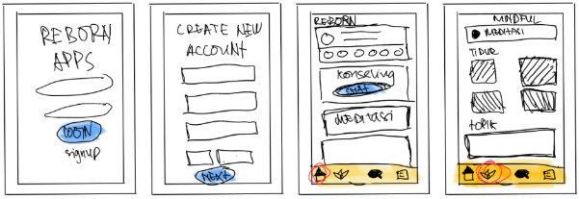

Figure 2 Wireframe design of the Reborn app

3.3.2 Hight Fidelity (Prototyping)

From the results of making Wireframe in the previous stage. Followed by giving colors, icons, buttons, and typography so that the wireframe becomes a clickable prototype which is a representation of the actual application. This prototype is made using Figma software. Figure 3 is an overview of prototyping for the Reborn application.

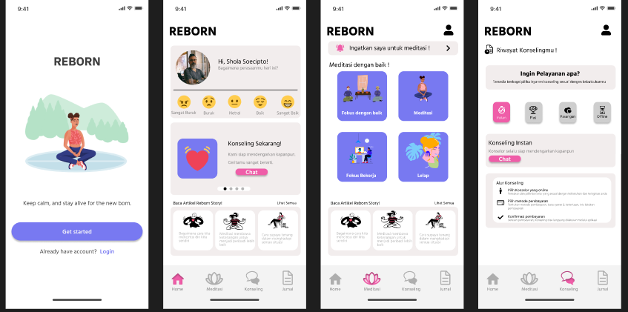

Figure 3 Proyotype Aplikasi Reborn

3.4 Run an Experience

The experimentation stage is carried out to find out the flow of the prototype that has been made previously at the MVP stage. Testing at this stage is done by testing independently to the target user. Independent testing is carried out in conjunction with MVP (Minimum Viable Product) design so that prototyping runs optimally. Testing is carried out on target users using a questionnaire conducted during the experiment, and the testing researcher will get feedback from the prototype design, which will be processed at the feedback and research stage which will help improve the prototype design.

3.5 Feedback and Research

System Usability Scale, When SUS was used, 10 respondents were asked to rate the following 10 items with one of five responses adopted from the standard SUS template ranging from Strongly Agree to Strongly Disagree.

Table 2 SUS Statement

|  |  |
| --- | --- |
| No | SUS Statement |
| 1. | I think I will use this system again |
| 2. | I find this system complicated to use. |
| 3. | I find this system easy to use |
| 4. | I need help from other people or technicians in using this system |
| 5. | I feel that the system features work as they should. |
| 6. | I feel many things are inconsistent (not harmonious) in this system |
| 7. | I feel like others will figure out how to use this system quickly. |
| 8. | I find this system confusing |
| 9. | I feel there are no obstacles to using this system. |
| 10. | I need to get used to it first before using this system. |

The results of calculating the SUS equation with the formula (questionnaire one - 1) + (5 - questionnaire two) can be seen in the calculated scores in Table 3. The average score of the final result can be found by the formula (number of calculated scores x 2.5) divided by 10 number of respondents. It can be seen that the final SUS score is 78.

Table 3 SUS Score

|  |  |  |  |  |  |  |  |  |  |  |  |  |
| --- | --- | --- | --- | --- | --- | --- | --- | --- | --- | --- | --- | --- |
| Respondent | SUS | | | | | | | | | | Total |  |
| Q1 | Q2 | Q3 | Q4 | Q5 | Q6 | Q7 | Q8 | Q9 | Q10 | Score |
| R1 | 4 | 4 | 4 | 4 | 4 | 3 | 4 | 4 | 3 | 4 | 38 | 95 |
| R2 | 4 | 2 | 4 | 3 | 4 | 2 | 4 | 2 | 2 | 2 | 29 | 73 |
| R3 | 3 | 4 | 3 | 3 | 3 | 3 | 2 | 3 | 4 | 3 | 31 | 78 |
| R4 | 4 | 3 | 4 | 4 | 4 | 3 | 4 | 4 | 4 | 2 | 36 | 90 |
| R5 | 3 | 3 | 3 | 3 | 3 | 3 | 3 | 3 | 3 | 3 | 30 | 75 |
| R6 | 3 | 3 | 3 | 3 | 4 | 4 | 4 | 3 | 4 | 3 | 34 | 85 |
| R7 | 3 | 4 | 3 | 3 | 3 | 4 | 3 | 3 | 3 | 3 | 32 | 80 |
| R8 | 4 | 3 | 4 | 3 | 4 | 2 | 4 | 3 | 2 | 4 | 33 | 83 |
| R9 | 3 | 3 | 4 | 3 | 4 | 3 | 4 | 4 | 3 | 4 | 35 | 88 |
| R10 | 2 | 4 | 4 | 2 | 2 | 4 | 2 | 2 | 2 | 4 | 28 | 70 |
| SUS Result | | | | | | | | | | | | 82 |

Table 3 explains in detail that SUS is in the acceptable/best category and can be promoted to respondents based on the calculation results. The SUS results have good usability for users, with the SUS score getting 82, which is above average and acceptable.

**Conclusion**

The design of the Reborn app was created using the Lean UX methodology and the design was used for wireframing using Figma. Applying the Lean UX methodology allows you to design and test applications, and ensure that the test results are aligned with your users' expectations.

Ten respondents participated in testing and evaluation using the Lean UX methodology, and SUS testing was evaluated during prototype design and development. It can be concluded that the Reborn application prototype has a good user experience and is acceptable to users. Positive user experience and usability improvements are important for further development of the mental health app prototype and play a key role in the acceptance, satisfaction, and efficiency of use of the Reborn app. The interface offers great ease of use and the SUS score is acceptable at 82.

Further research requires increasing the number of respondents to refine the next survey and testing more diverse ways of measuring UX levels.

**Reference**

[1] E. W. Sulistyo dan S. Sofiana, “Perancangan Desain User Interface/User Experience Web Layanan Informasi Kamus Dengan Metode Lean User Experience (Lean UX) Pada Universitas Pamulang,” *BULLET : Jurnal Multidisiplin Ilmu*, vol. 1, no. 03, hlm. 357–368, 2022.

[2] J. Jocelyn dan R. P. Sutanto, “Penerapan Metode Lean UX dan Design Sprint Pada Pembuatan dan Pengembangan Aplikasi Aryanna,” *Jurnal DKV Adiwarna*, vol. 1, hlm. 9, 2022, [Daring]. Tersedia pada: https://www.plainconcepts.com/lean-ux-methodology/

[3] A. K. Rofik, T. Sagirani, dan H. E. Wulandari, “Desain Prototipe Pada Startup Talentku Menggunakan Metode Lean UX Startup,” *Jurnal Teknologi dan Terapan Bisnis*, vol. 3, no. 2, hlm. 49–59, 2020.

[4] D. A. Anggara, W. Harianto, dan A. Aziz, “Prototipe Desain User Interface Aplikasi Ibu Siaga Menggunakan Lean Ux,” *Kurawal - Jurnal Teknologi, Informasi dan Industri*, vol. 4, no. 1, hlm. 58–74, 2021, doi: 10.33479/kurawal.v4i1.403.

[5] F. Hasibuan, H. Setiawan, E. Ali, dan Junadhi, “Prototype Design User Interface Sistem Preloved Menggunakan Metode Lean Ux,” *ZONAsi: Jurnal Sistem Informasi*, vol. 5, no. 1, hlm. 137–148, 2023, doi: 10.31849/zn.v5i1.12915.

[6] A. A. Hendriadi dan A. Primajaya, “Optimization of financial technology (fintech) with lean UX development methods in helping technical vocational education and training financial management,” *IOP Conf Ser Mater Sci Eng*, vol. 830, no. 2, 2020, doi: 10.1088/1757-899X/830/2/022088.

[7] A. Wijanarko, F. Solikhin, E. Antoni, dan H. N. Fadhil, “Implementasi Metode Lean UX dan Efek Positifnya Pada Pengembangan Game Edukasi Berbasis Android Materi Ikatan Kimia,” *JTKSI (Jurnal Teknologi Komputer dan Sistem Informasi)*, vol. 6, no. 1, hlm. 58, 2023, doi: 10.56327/jtksi.v6i1.1394.

[8] J. Pilz, J. Deutschländer, J. Thomaschewski, dan E. M. Schön, “Integrating Agile Human-Centered Design with LeanUX and Scrum,” *International Conference on Web Information Systems and Technologies, WEBIST - Proceedings*, vol. 2021-Octob, no. Webist, hlm. 467–473, 2021, doi: 10.5220/0010713800003058.

[9] T. Tiawan dan N. Rahmawati, “Implementasi Flutter Framework & Metodologi Lean UX Kanban Dalam Aplikasi Reservasi The Bbalbong,” *Jurnal Fokus Elektroda : Energi Listrik, Telekomunikasi, Komputer, Elektronika dan Kendali)*, vol. 7, no. 2, hlm. 116, 2022, doi: 10.33772/jfe.v7i2.15629.

[10] K. KHADIJAH, “Studi Perbandingan Metodologi Ui/Ux (Studi Kasus: Prototype Aplikasi Pdbi Academic Information System),” *KNOWLEDGE: Jurnal Inovasi Hasil Penelitian dan Pengembangan*, vol. 2, no. 4, hlm. 292–301, 2023, doi: 10.51878/knowledge.v2i4.1808.

[11] Y. Prayoga, Nanda; Afni, Nur; Putra, Andicha; Efendi, “Pengembangan UX Aplikasi Panji Wedding Organizer Kota Pekanbaru Menggunakan Metode Lean UX,” *SATIN - Sains dan Teknologi Informasi*, vol. 8, no. 2, hlm. 58–67, 2022, doi: 10.33372/stn.v8i2.863.

[12] R. Prihatini dan T. Widodo, “Implementation of Lean UX for Coworking Space Booking Room Application Design,” *Int J Comput Appl*, vol. 185, no. 17, hal. 54–60, 2023, doi: 10.5120/ijca2023922894.

[13] D. A. Ariyoga, A. Sukmaaji, dan D. Sunarto, “Analisis Dan Perancangan UI/UX Aplikasi E-Commerce Berbasis pada Model Lean User Experience,” *Jsika*, vol. 11, no. 2, hlm. 81–94, 2022, [Daring]. Tersedia pada: https://www.vodjo.com/

[14] R. A. Malik dan M. R. Frimadani, “UI/UX Analysis and Design Development of Less-ON Digital Startup Prototype by Using Lean UX,” *Jurnal RESTI (Rekayasa Sistem dan Teknologi Informasi)*, vol. 6, no. 6, hlm. 958–965, 2022, doi: 10.29207/resti.v6i6.4454.

[15] K. V. Sibuea dan Y. Windarto, “Pengembangan UI/UX Pada Fitur IVT: Loan Calculator Dengan Metode Lean UX (Studi Kasus: X By PT.XYZ),” *Jurnal Teknik Informatika dan Sistem Informasi*, vol. 10, no. 1, hlm. 107–118, 2023, [Daring]. Tersedia pada: http://jurnal.mdp.ac.id

[16] A. S. Nursyifa; Mayasari, Rini; Yuda Irawan, “Implementation Of Lean UX Method on UI/UX Design of Digilib UNSIKA application in Windows Version,” vol. 04, hlm. 1–23, 2021.